**WEEK-10 Tutorial (ICT502)**

**Student ID: S20241757**

**Student Name: RAHUL TUNDIYA**

**Database Administration and Security**

# Solutions to Stop SQL Injection

**Validation and Sanitization**

Description: Validate and sanitize all user inputs to make sure they comply with predicted codecs and reject any that include doubtlessly harmful SQL syntax.

Implementation: Use validation libraries and features for your programming language to test and sanitize entered data.

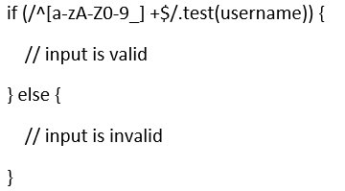

**Use ORM (Object-Relational Mapping) frameworks.**

Description: ORM frameworks offer an abstraction layer over the database and use methods that might be inherently safe from SQL injection.

Implementation: Utilize ORM frameworks like Hibernate for Java, Entity Framework for.NET, or Django ORM for Python.

**Least Privilege Principle**

Description: Limit the database permissions granted to software cost owed to the best what is essential. This minimizes the potential harm from an SQL injection assault.

Implementation: Create specific database customers with restricted permissions and roles.

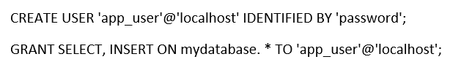

# Solutions to Stop DoS Attacks

**IP Blacklisting and whitelisting**

 Description: Block traffic from known malicious IP addresses or permit visitors simplest to rely on IP addresses.

Implementation: Use firewall rules, server configuration, or third-party services to manage IP lists.

**Content Delivery Networks (CDN)**

Description: CDNs distribute content material throughout more than one server globally, lowering the load on the foundation server and mitigating the impact of DoS attacks.

Implementation: Integrate a CDN like Cloudflare, Akamai, or Amazon CloudFront to cache and serve content material in the direction of the user.

**Intrusion Detection and Prevention Systems (IDPS)**

Description: IDPS displays community visitors for suspicious activities and can block or mitigate attacks in real time.

Implementation: Deploy IDPS answers like Snort, Suricata, or OSSEC to discover and save you from DoS assaults.